**Security RESTAPIs with spring security:**

**Step1**:Go to chrome and give spring.initializer.io

Add Dependencies: Spring Web, Spring Security, Spring Boot Dev Tools

And select the options as shown in the image below

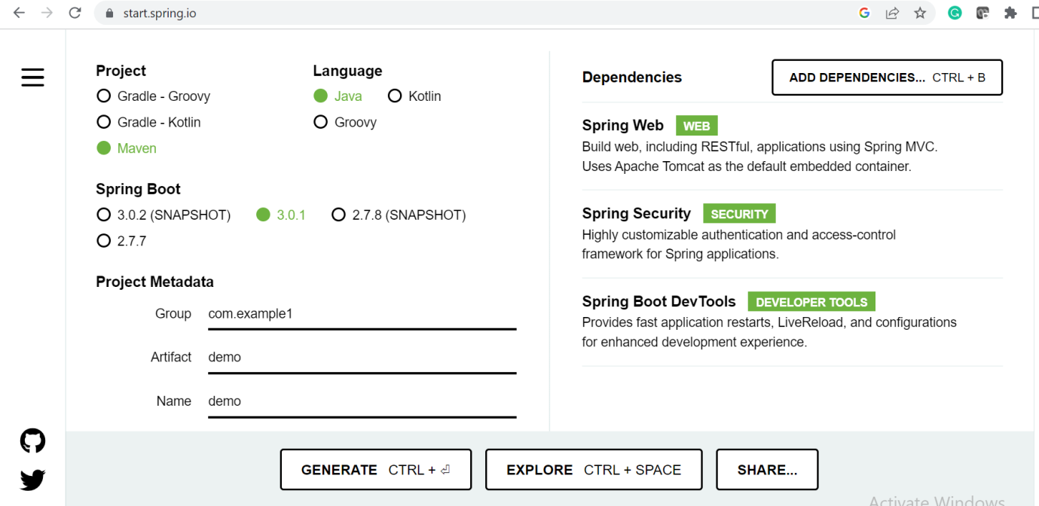

Click on **generate**. Now the zip file comes up.Unzip this file

**Step2:** Go to eclipse and click on File. Click on open project from file.Select Directory and choose the path of the file(unzipped file path)

**Step3:** Demo project appears with the standard spring boot application file format

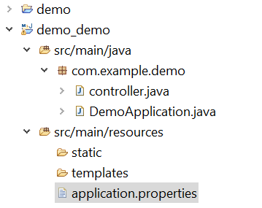

**Step4:** By default the class DemoApplication.java will be there

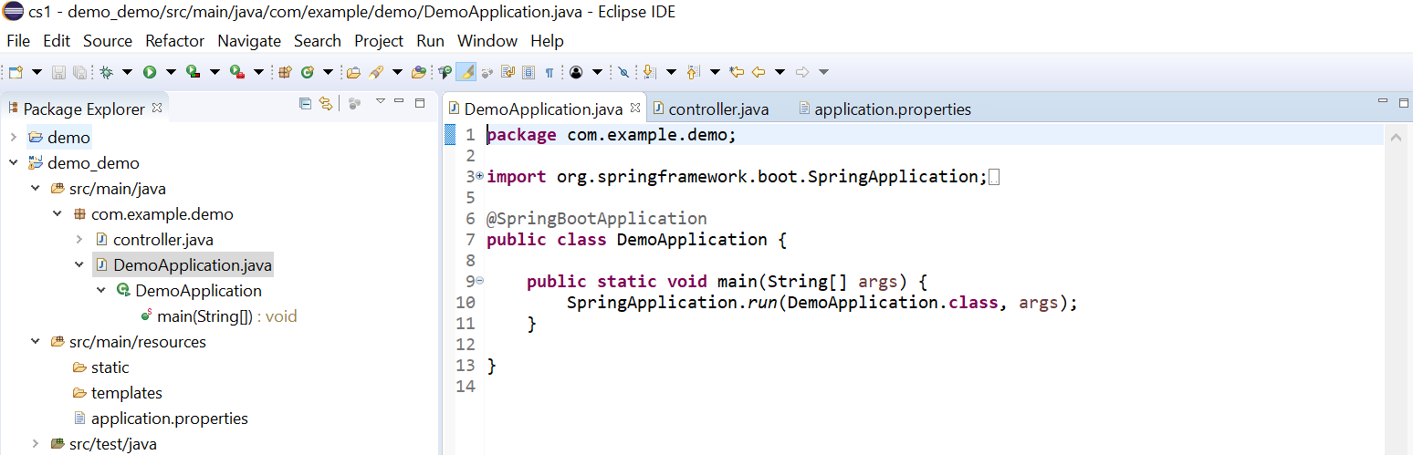

**Step5** :Now right click on the project select new then select class and give the name of the class as controller.Create the simple REST API inside this class

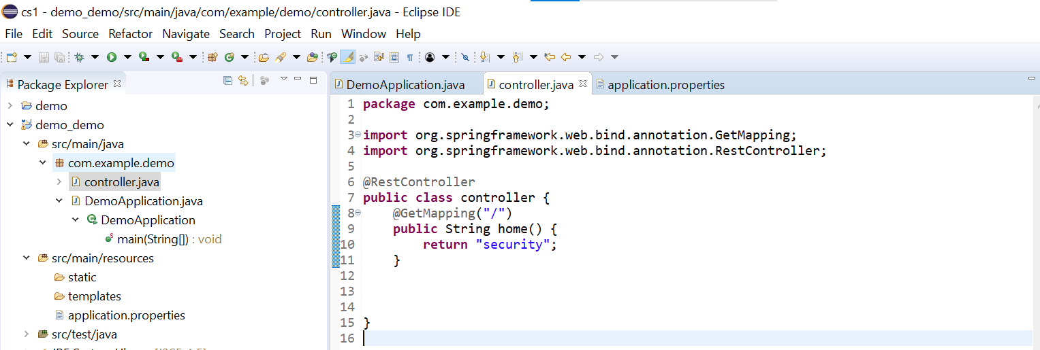

**Step6:** To give security ,open application.properties file and give the name and password

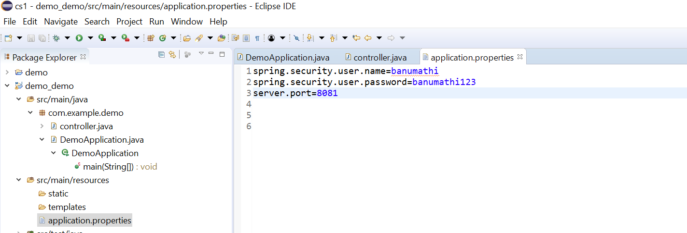

**Step7:** Now run the class DemoApplication.java and the output will be like this as shown below

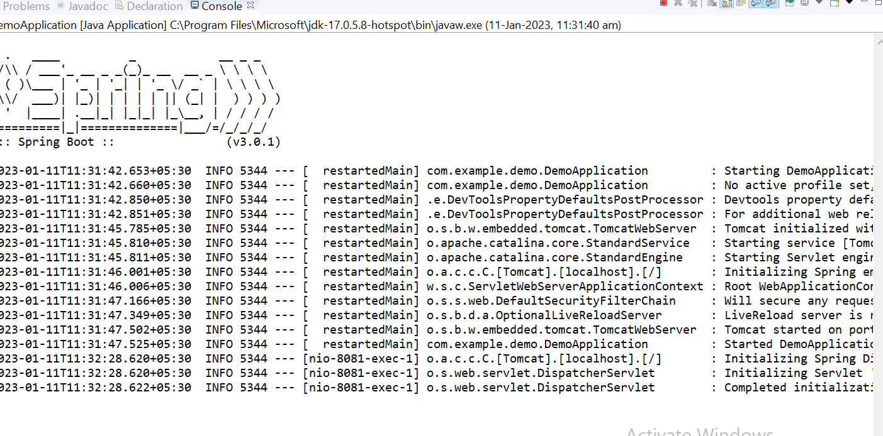

**Step8:** Now go to browser and give localhost:8081

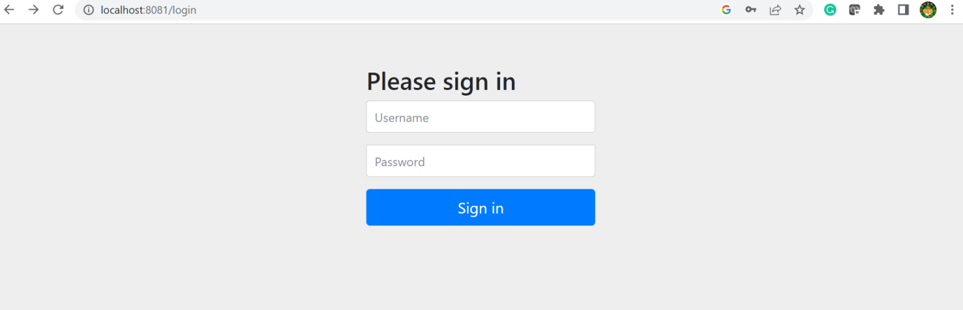

**Step9:** Give the username and password

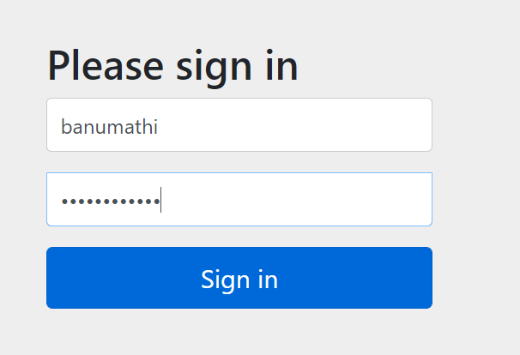

Step10: Now our application appears

